Sample paper class 10th
Q1 A chemical reaction does not involve:
a. Formation of new substances having entirely different properties than that of the reactants
b. Breaking of old chemical bonds and formation of new chemical bonds
c. Rearrangement of the atoms of reactants to form new products
d. Changing of the atoms of on element into those of another element to form new products
Answer. d. Changing of the atoms of on element into those of another element to form new products
Q2 One of the following processes does not involve a chemical reaction. That is:
a. Melting of candle wax when heated
b. Burning of candle wax when heated
c. Digestion of food in our stomach
d. Ripening of banana
Answer. a. Melting of candle wax when heated
Q3 It is necessary to balance a chemical equation in order to satisfy the law of:
a. Conservation of motion
b. Conservation of momentum
c. Conservation of energy
d. Conservation of mass
Answer. d. Conservation of mass
Q4 All the methods mentioned below can be used to prevent the food from getting rancid except:
i. Storing the food in the air-tight containers
ii. Storing the food in refrigerator
iii. Keeping the food in clean and covered containers
iv. Always touching the food with clean hands
a. (i) and (ii)
b. (i) and (iii)
c. (i), (iii) and (iv)
d. (iii) and (iv)
Answer. d. (iii) and (iv)
Q5 Rusting of iron involves a chemical reaction which is a combination of:
a. Reduction as well as combination reactions
b. Oxidation as well as combination reactions
c. Reduction as well as displacement reactions
d. Oxidation as well as displacement reactions
Answer. b. Oxidation as well as combination reactions
Q6. You are given the following chemical reaction:
This reaction represents:
a. Combination reaction as well as double displacement reaction
b. Redox reaction as well as displacement reaction
c. Double displacement reaction as well as redox reaction
d. Decomposition reaction as well as displacement reaction
Answer. b. Redox reaction as well as displacement reaction
Q7 When ferrous sulphate is heated strongly it undergoes decomposition to form ferric oxide as a main product accompanied by a change in colour from:
a. Blue to green.
b. Green to blue.
c. Green to brown.
d. Green to yellow.
Answer. c. Green to brown
Q8 Which of the following gases is used in the storage of fat and oil containing foods for a long time?
a. Carbondioxide gas
b. Nitrogen gas
c. Oxygen gas
d. Neon gas
Answer. b. Nitrogen gas
Q9 Following is given a diagram showing an experimental set-up:
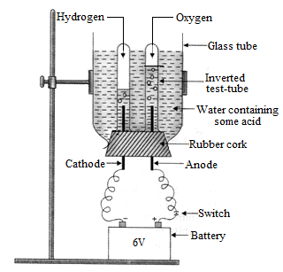
The given set-up is used to carry out:
a. Distillation of water
b. Purification of water
c. Electrolysis of water
d. Hydrolysis
Answer. c. Electrolysis of water
Q10. The respiration process during which glucose undergoes slow combustion by combining with oxygen in the cells of our body to produce energy, is a kind of:
The displacement reaction between iron (III) oxide and a metal X is used for welding the rail tracks. Here X is:
a. Copper granules
b. Magnesium ribbon
c. Sodium pellets
d. Aluminium dust
Answer. d. Aluminium dust
Q11. If in the given arrangement, the three resistors are to be replaced by a single resistor. What will be the value of this resistor?
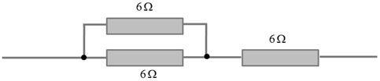
(a) 4Ω
(b) 6Ω
(c) 9Ω
(d) 18Ω
Answer: (c) 9Ω
Q12 The potential difference across the 3 Ω resistor in the following diagram is:
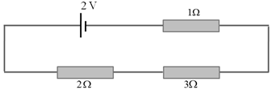
(a) 1/9 V
(b) 1/2 V
(c) 2V
(d) 1V
Answer: (d) 1V
Q13 V₁, V₂ and V₃ are the potential differences across the 1Ω, 2Ω and 3Ω resistors in the following diagram, and the current is 5A.
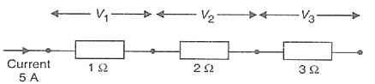
Which of the following shows the correct values of V₁, V₂ and V₃ measured in volts?
(a) V₁ =1, V₂ = 2 and V₃ = 3
(b) V₁ =5, V₂ = 10 and V₃ = 15
(c) V₁ =5, V₂ = 2.5 and V₃ = 1.6
(d) V₁ =4, V₂ = 3 and V₃ = 2
Answer: (b)
Q13 If a normal cell of human body contains 46 pairs of chromosomes then the numbers of chromosomes in a sex cell of a human being is most likely to be:
(a) 60
(b) 23
(c) 22
(d) 40
Answer. (b) 23
Explanation: The sex gametes are always haploid. They have 23 chromosomes.
Q14 In the human blood grouping, the four basic blood types are type A, type B, type AB, and type O. They are:
(a) Simple dominant and recessive traits
(b) Co-dominant traits
(c) Recessive traits
(d) Inherited traits
Ans: (b) Co-dominant traits
Explanation: A co-dominant trait is the one in which neither allele is dominant or recessive and both are expressed equally.
Q15 A pregnant woman has an equal chance of her baby being blood group A or blood group AB. Which one of the following shows the possible genotypes of the woman and the father of her child?
(a) I^{A} I^{A} and I^{B} I^{O}
(b) I^{A} I^{B} and I^{B} I^{O}
(c) I^{A} I^{O} and I^{B} I^{O}
(d) I^{O} I^{B} and I^{A} I^{O}
Answer. (a) I^{A} I^{A} and I^{B} I^{O}
Q16. What will be the number of chromosomes present in each gamete produced by the plants if the palisade cells of a species of plant contain 28 chromosomes in all?
(a) 56
(b) 28
(c) 14
(d) 4
Answer. (c) 14
Q17 The following results were obtained by a scientist who crossed the F₁ generation of pure-breeding parents for round and wrinkled seeds.
Dominants trait | Recessive trait | No. of F₂ offspring
Round seeds | Wrinkled seeds | 7524
From these results, it can be concluded that the actual number of round seeds he obtained was:
(a) 1881
(b) 22572
(c) 2508
(d) 5643
Answer. (d) 5643
Explanation: The actual number of seeds obtained were 5643.
Q18 A cross between a tall plant (TT) and short plant (tt) resulted in progeny that were all tall plants as:
(a) Tallness is the dominant trait
(b) Shortness is the dominant trait
(c) Tallness is the recessive trait
(d) Height of plant is not governed by gene t or t
Answer. (a) Tallness is the dominant trait
Explanation: The best traits are always superior. For instance, tallness and round seeds are dominant traits.
Q19 In peas, a pure tall plant (TT) is crossed with a pure short plant (tt). The ratio of pure tall plants to pure short plants in F₂ generation will be:
(a) 1 : 3
(b) 3 : 1
(c) 1 : 1
(d) 2 : 1
Answer. (c) 1 : 1
Explanation: The ratio of TT and tt plants of F₂ generation will be the same.
Q20. In human males, all the chromosomes are paired perfectly except one. These unpaired chromosomes are:
(i) Large chromosome
(ii) Small chromosome
(iii) Y chromosome
(iv) X chromosome
(a) (i) and (ii)
(b) (iii) and (ii)
(c) (iii) and (iv)
(d) (ii) and (iv)
Answer. (c) (iii) and (iv)
Explanation: X and Y are sex chromosomes.
Q21. Which of the following determines the sex of a child?
(a) The length of the mother’s pregnancy
(b) The length of time between ovulation and copulation
(c) The presence of an X chromosome in an ovum
(d) The presence of a Y chromosome in a sperm
Answer. (d) The presence of a Y chromosome in a sperm
Explanation: The male sex chromosome is the deciding factor for the gender of the child. If the X part fertilizes with the ovum, girl is born. If Y fertilizes, then a boy is born.
Q22 Which is the one characteristic of the parents that can be inherited by their children?
(a) Deep scar on chin
(b) Snub nose
(c) Technique of swimming
(d) Cut nose
Answer. (b) Snub nose
Explanation: A dominant inherent character can only be inherited by the children.
Q23. What could be the reason for the fossil of an organism to be found in the deeper layers of the earth?
(a) The extinction of organism has occurred few years back
(b) The extinction of organism has occurred thousands of years ago
(c) The position of fossil in the layers of earth is not related to its time of extinction
(d) Time of extinction cannot be determined.
Answer. (b) The extinction of organism has occurred thousands of years ago
Explanation: The deeper the fossil is embedded in the earth, the more likely it is to be very old.
Q24 What is the ancient name for all human beings?
(a) Monkey
(b) Chimpanzee
(c) Homo sapiens
(d) Invertebrates
Answer. (c) Homo sapiens
Q25 The organs present in two organisms indicate that they are derived from the same ancestor are:
(a) Analogous Organs
(b) Respiratory Organs
(c) Sense organs
(d) Homologous Organs
Answer. (d) Homologous Organs
Explanation: The structures which are similar in their morphology, anatomy, and embryology but dissimilar in their functions are homologous organs.
Q26 Which of the following pair of organ is not homologous?
(a) Forelimbs in humans and lizard
(b) Forelimbs in lizard and frog
(c) Wings in butterfly and bat
(d) None of these
Answer. (c) Wings in butterfly and bat
Q27A student does the experiment on tracing the path of a ray of light passing through a rectangular glass slab for different angles of incidence. He can get a correct measure of the angle of incidence and the angle of emergence by following the labelling indicated in figure:
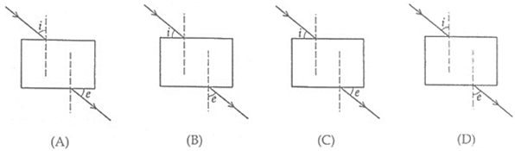
(a) A
(b) B
(c) C
(d) D
Answer: (d) D
Q28 While performing an experiment on determination of focal length of a convex lens, four students obtained the image of the same distant tree on the screen as follows:
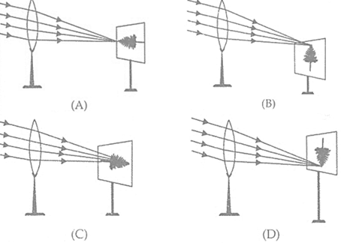
Which diagram shows the formation of image correctly?
(a) A
(b) B
(c) C
(d) D
Answer: (d) D
Q29 A student traces the path of a ray of light passing through a rectangular slab.
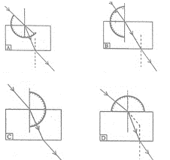
For measuring the angle of incidence, he must position the protractor in the manner shown in the figure:
(a) A
(b) B
(c) C
(d) D
Answer: (d) D
Q29 Four students A, B, C and D performed the experiment to determine the focal length of a concave mirror by obtaining the image of a distant tree on a screen. They measured the distances between the screen and the mirror as shown in the diagrams given below:
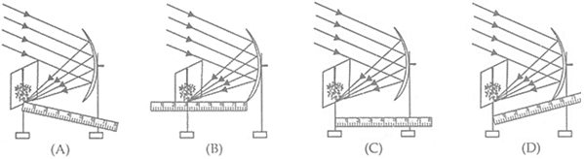
The correct way to measure accurate focal length of the mirror is:
(a) A
(b) B
(c) C
(d) D
Answer: (c) C
Q30 A student traces the path of a ray of light passing through a rectangular slab for three different values of angle of incidence (∠i ) namely 30º, 45º and 60º. He extends the direction of incident ray by a dotted line and measures the perpendicular distance ‘l’ between the extended incident ray and the emergent ray.
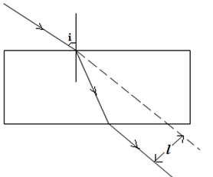
He will observe that:
(a) ‘l’ keeps on increasing with increase in angle of incidence
(b) ‘l’ keeps on decreasing with increase in angle of incidence
(c) ‘l’ remains the same for all three angles of incidence
(d) ‘l’ is the maximum for ∠i = 45º and is less than this value for ∠i = 30º and ∠i = 60º.
Answer: (a) ‘l’ keeps on increasing with increase in angle of incidence
Q31 The number of protons in an atom of an element A is 19 then, the number of electron in its ion A⁺ is:
a) 18
b) 19
c) 20
d) 21
Answer: (a) 18
Q32 Bauxite is an ore of
a) Iron
b) Aluminium
c) Mercury
d) Copper
Answer: (b) Aluminium
Explanation: Bauxite is a commercial ore of aluminium which consists largely of hydrated aluminium oxide, Al₂O₃.2H₂O.
Q33 The metal which is liquid at room temperature is
a) Bromine
b) Mercury
c) Iodine
d) Potassium
Answer: (b) Mercury
Explanation: Mercury is the only metal which exists as a liquid at room temperature.
Q34The sulphide ores are converted into oxides by heating strongly in the presence of excess air. This process is known as
a) Roasting
b) Smelting
c) Calcination
d) Refining
Answer: (a) Roasting
Q35 In electrolytic refining, the cathode is made up of
a) Pure metal
b) Impure metal
c) Alloy
d) Metallic salt
Answer: (a) Pure metal
Explanation: In electrolytic refining of a metal, the cathode is made up of pure metal whereas the anode is made up of impure metal.
Q36 In the given reaction, Al₂O₃ + NaOH → ……X…… + H₂O
What is element X?
a) NaAlO₂
b) Na₃Al
c) Na₂O₃
d) NaAl₂O₃
Answer: (a) NaAlO₂
Explanation: Aluminium oxide is amphoteric in nature, i.e., it reacts with acids as well as bases to form salt and water.
Here, aluminium oxide behaves as an acid as it reacts with NaOH, a base and forms sodium aluminate (NaAlO₂) and water:
Al₂O₃ + NaOH → 2NaAlO₂+ H₂O
Q37. Which of the following represent the correct order of decreasing reactivity?
a) Mg > Al > Zn > Fe
b) Mg > Zn > Al > Fe
c) Al > Zn > Fe > Mg
d) Mg > Fe > Zn > Al
Answer: (a) Mg > Al > Zn > Fe
Explanation: The decreasing order of the reactivity of the common metals is given below:
Li, K, Na, Ba, Ca, Mg , Al, Mn, Zn, Fe, Ni, Sn, Pb, [H], Cu,Hg, Ag, Au,Pt
Q38 An element reacts with oxygen to give a compound with a high melting point. This compound is also soluble in water. The element is likely to be
(a) Ca
(b) C
(c) Si
(d) Fe
Answer: (a) Ca
Explanation:
Calcium reacts with oxygen to give calcium oxide (CaO) which is having a high melting point and dissolves in water to form calcium hydroxide (Ca(OH)₂)along with the release of large amount of thermal energy.
Q39. Which of the following pairs will give displacement reactions?
(a) NaCl solution and copper metal
(b) MgCl₂ solution and aluminium metal
(c) FeSO₄ solution and silver metal
(d) AgNO₃ solution and copper metal
Answer: (d) AgNO₃ solution and copper metal
Explanation: Copper (Cu) being more reactive than silver (Ag), displaces silver from silver nitrate (AgNO₃) to form copper nitrate
2AgNO₃ + Cu → Cu(NO₃)₂+ 2Ag
Q40. Which among the following is the most abundant metal found in the earth’s crust?
(a) Magnesium
(b) Aluminium
(c) Oxygen
d) Iron
Answer: (b) Aluminium

. How eyes adjust in order to focus the image of near or distant objects on retina?
(a) The lens moves in or out according to the position of the object
(b) The retina moves in or out according to the position of the object
(c) The lens becomes thicker or thinner according to the position of the object
(d) The pupil gets larger or smaller according to the position of the object
Answer: (c) The lens becomes thicker or thinner according to the position of the object
Q43. A person cannot see the distant objects clearly (though he can see the nearby objects clearly). He is suffering from the defect of vision called:
(a) Cataract
(b) Hypermetropia
(c) Myopia
(d) Presbyopia
Answer: (c) Myopia
Q44. A got his eye tested. The optician’s prescription for the spectacles was:
Left eye: −3 D
Right eye: −3.50 D
The person is having a defect of vision called:
(a) Presbyopia
(b) Myopia
(c) Astigmatism
(d) Hypermetropia
Answer: (b) Myopia
Q45. A man finds it difficult to read the odometer on the dashboard of the car but is able to clearly read a distant road sign. Which of the following statement is correct about this man?
(a) The near point of his eyes has receded away.
(b) The near point of his eyes has come closer to him.
(c) The far point of his eyes has receded away.
(d) The far point of his eyes has come closer to him.
Answer: (a) The near point of his eyes has receded away
Q46. Which of the following figures correctly represents the passage of white light through prism?
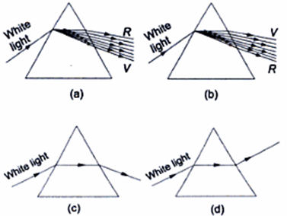
Answer: (a)
Q47 Which of the following graph represents the correct variation of angle of incidence (i) and angle of deviation (δ)?
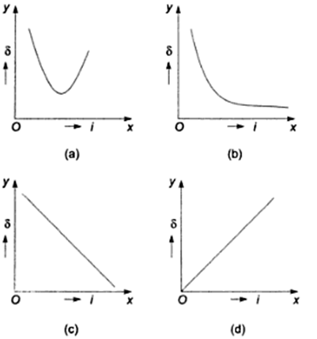
Answer: (a)
Q48 Figure a, b, c respectively; indicate the point in case of:
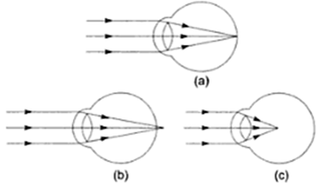
(a) The Hypermetropia eye, the myopic eye and normal eye
(b) The normal eye, the myopic eye and Hypermetropia eye
(c) The normal eye, the Hypermetropia eye and myopic eye
(d) The myopic eye, the normal eye and Hypermetropia eye
Answer: (c) The normal eye, the Hypermetropia eye and myopic eye
Q49. In which of the following cases will no dispersion take place when sunlight passes through it?
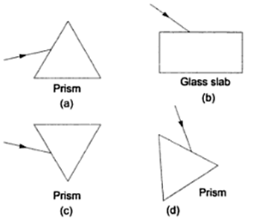
Answer: (b)
Q50 In a chemical reaction between sulphuric acid and barium chloride solution the white precipitates formed are of:
a. Hydrochloric acid
b. Barium sulphate
c. Chlorine
d. Sulphur
Answer. b. Barium sulphate

